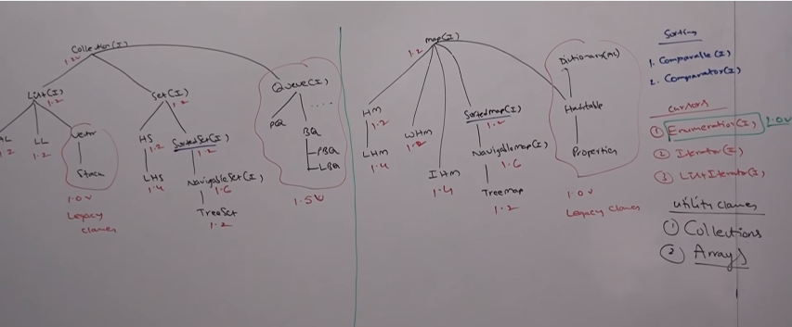

**Method in List**

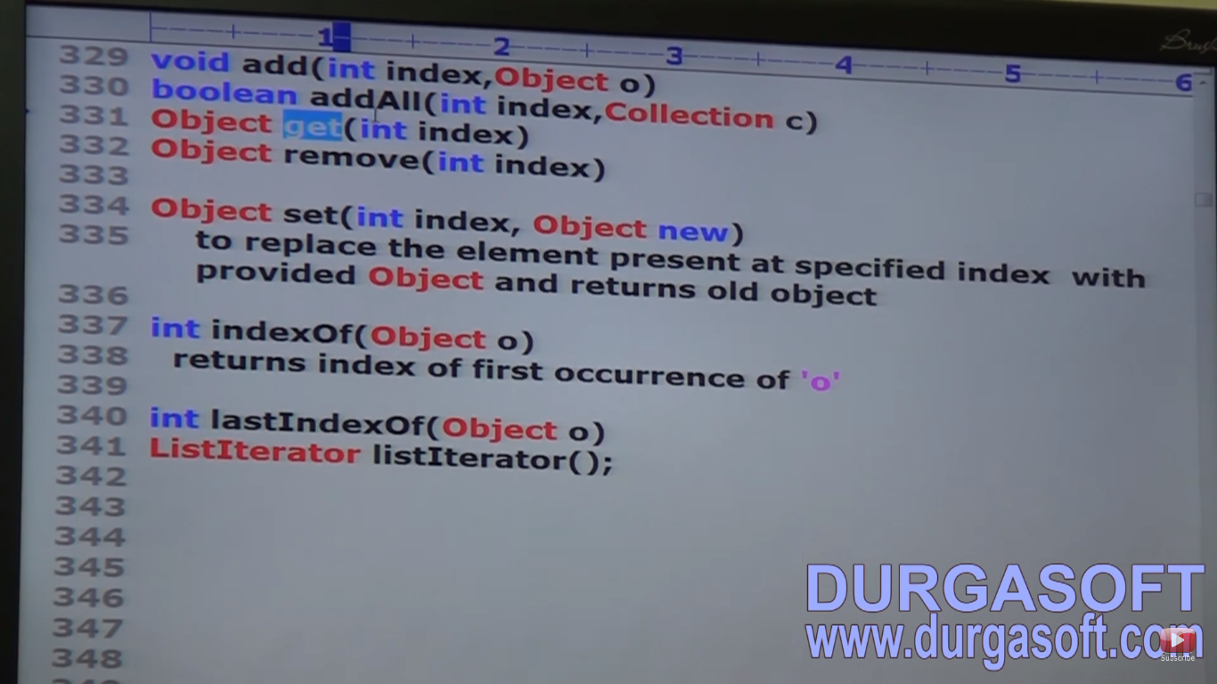

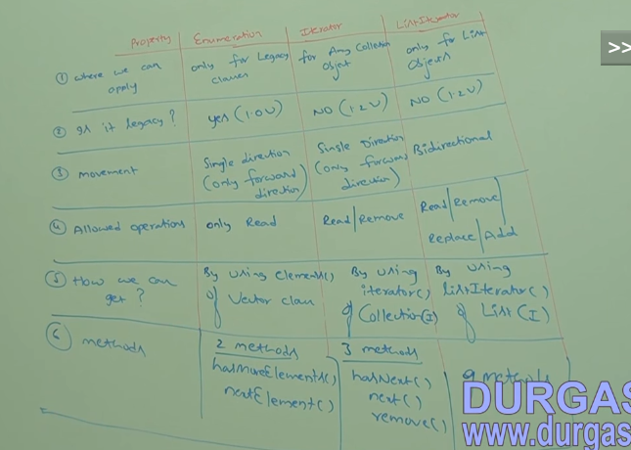

**Arrays:**

1. Arrays concept is not implemented based on some standard data structure and hence readymade support is not available. For every requirement we have to write the code explicitly which increases the complexity of the program.
2. Arrays can contain only homogenous data types. But luckily we can solve this problem by using Object class.

Object[] o=new Object[];

o[0]= new Student();

1. Size is fixed.

**NOTE : Collections are not good performance wise but arrays are good if you are considering performance. Arrays is a java language feature but collection is an api.**

**NOTE : Collections can not hold primitive data-types i.e, only Objects. But Array can hold both.**

The reason why collection is not good at performance because to make any collection class growable there is lot of internal working is required.

Suppose you create an arrayList which have a definite size at first. When u fill it then a new ArrayList is created with double the size and the contents of old arrayList is copied to this new sized ArrayList. After copying the reference is changed from the old ArrayList to this new sized ArrayList. Hence a lot of working is required internally to achieve this growable functionality.

Collection is a group of objects in a single entity. To put group of objects into single entity several classes and interfaces are required which is called as collection framework.

**Vector/ArrayList:**

1. Its structure is resizable array and growable array.
2. Duplicate objects are allowed.
3. Insertion order is preserved.
4. Null insertion is possible.
5. Heterogeneous objects are allowed. (Except in TreeSet and TreeMap)
6. It implements RandomAccess, Seriliazable and clonable interface.
7. **Most of the methods present in the vector are synchronized. (it is the only diff btw ArrayList).**
8. It is the best choice when the frequent operation is retrieval.
9. It is a legacy class(1.0v).
10. By default ArrayList is non synchronized but we can make it synchronized by using **synchronizedList() method of Collections class.**

**Public static List synchronizedList(List l)**

**Public static Set synchronizedSet(Set s)**

**Public static Map synchronizedMap(Map m)**

**ArrayList al=new ArrayList();** *//It is not synchronized //default capacity: 10*

**List l=Collections.synchronizedList(al);** *//Now it is Synchronized*

**HashSet hs=new HashSet();***//It is not synchronized*

**Set s=Collections.synchronizedSet(hs);** *//Now it is Synchronized*

**HashMap hm=new HashMap();***//It is not synchronized*

**Map m=Collections.synchronizedMap(hm);** *//Now it is Synchronized*

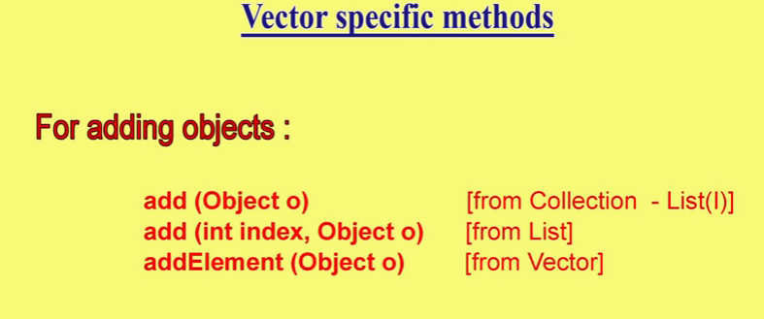

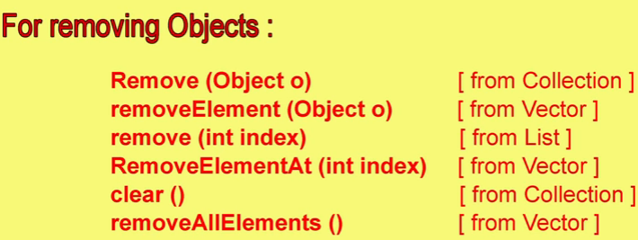

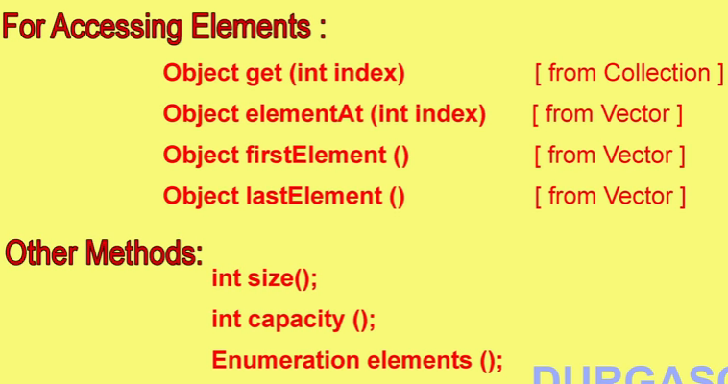

**Vector class constructor:**

1. Default vector constructor: **Vector v=new Vector();// ArrayList a=new ArrayList();**

This has the default initial capacity =10

Once it reaches its limit a bigger vector object will be created with a capacity of **2*current capacity**.

While in array list the new capacity will be **(current*3/2)+1. In java7: current>>1**

1. If we know the capacity of elements then we can create our required capacity vector. It will increase performance as bigger vector will not have to be created repeatedly like 10 then 20 then 40.

**Vector v=new Vector(int initialCapacity);// ArrayList a=new ArrayList(int initialCapacity);**

1. Vector v=new Vector(int initialCapacity, int incrementalCapacity); (It is not in ArrayList)
2. **Vector v=new Vector(Collection c); // ArrayList a=new ArrayList(Collection c);**

**class** Test {

**public** **static** **void** main(String[] args) {

Vector v = **new** Vector(); **or**

Vector v = **new** Vector(10); **or**

Vector v = **new** Vector(20,5);

System.*out*.println("Vector capacity before :: " + v.capacity());

**for** (**int** i = 1; i <= 10; i++) {

v.addElement(i);

}

System.*out*.println("Vector capacity :: " + v.capacity());

v.addElement("A");

System.*out*.println("Vector capacity after adding A :: " + v.capacity());

System.*out*.println(v);

}

}

**Output:**

**Vector capacity before :: 10**

**Vector capacity :: 10**

**Vector capacity after adding A :: 20**

**[1, 2, 3, 4, 5, 6, 7, 8, 9, 10, A]**

**Output:**

**Vector capacity before :: 10**

**Vector capacity :: 10**

**Vector capacity after adding A :: 20**

**[1, 2, 3, 4, 5, 6, 7, 8, 9, 10, A]**

**Output:**

**Vector capacity before :: 20**

**Vector capacity :: 20**

**Vector capacity after adding A :: 25**

**[1, 2, 3, 4, 5, 6, 7, 8, 9, 10, A]**

NOTE 1: In the above the elements are printed in square bracket because internally toString() method is called i.e, syso(v)======syso(v.toString());

**Question: Why all collection classes implements Serializable and Clonable interface??**

Answer:

If we want to transfer object from one place to another place then the object should be serializable. To provide this facility all the collection classes by default implement Serializable interface.

Suppose we have a Array List object which contains collection of student objects and it have to be transferred across the network. As all the collection classes are serialized therefore it can be transferred through the network.

After this object reaches to the receiver, receiver directly don’t handle this object because if anything goes wrong then the object can be damaged, so a exact copy of that object is created and this process is known as Cloning and hence to provide this facility all collection classes implements Clonable interface.

**Question: Why ArrayList and Vector implements RandomAccess Interface??**

Answer:

To access any element with same speed it is mandatory that you implement RandomAccess Interface. Whether it be 1st element or 1 crore element it will take the same time.

**NOTE: RandomAccess is a marker interface in java.util and is only implemented by ArrayList and Vector. So if the process is to retrieve element it is highly recommended that we should use ArrayList as it implements RandomAccess interface.**

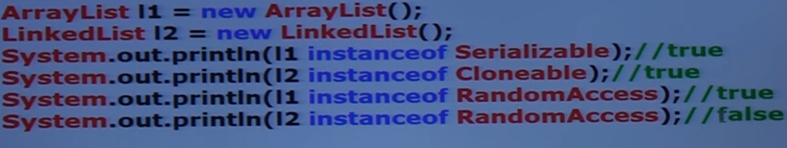

* If we want to insert or remove any element from any position then lot of shifting is to be required and that will consume a lot of time. hence in this case using ArrayList will be the worst choice and LinkedList is the best choice. It is best in case of retrieval.

**Internal working of ArrayList:**

When we create the arrayList, it internally create the object array of default size: 10

ArrayList list=new ArrayList(); = Object[] list =new Object[10];

If the arrayList is full then it dynamically grows its size by creating the bigger object array and copying the old array to it and changing the reference by using Arrays.CopyOf(old array , newLength) function.

New length is calculated as oldLength>>1

***LinkedList:***

1. Structure is Double linked list .
2. Insertion order is maintained
3. Heterogeneous elements are allowed.
4. Null insertion is possible.
5. It implements Serializable and cloneable interface but not RandomAccess interface.
6. Default capacity is not there in LinkedList as an empty LinkedList is created at first.

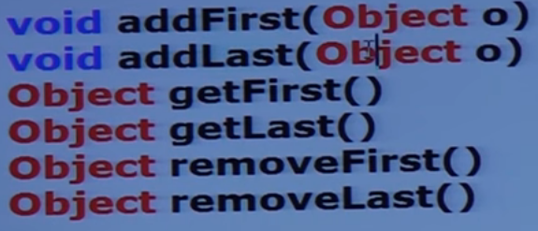

**public** **class** Test {

**public** **static** **void** main(String[] args) {

List<String> list = **new** ArrayList<>();

Iterator<String> itr = list.iterator();

ListIterator<String> lItr = list.listIterator();

System.***out***.println(itr.getClass().getName());

System.***out***.println(lItr.getClass().getName());

}

}

**Output:**

java.util.ArrayList$Itr

java.util.ArrayList$ListItr

In the above we can see that we are not creating an object by list.iterator() but it returns the object of the inner class that implements it.

***Set:***

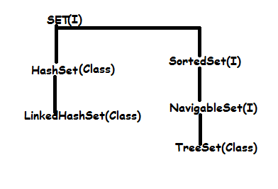

1. Duplicates are not allowed in set. If duplicate element is added then add method will simply return false.
2. Insertion order is not preserved. All objects will be inserted according to the hash code.
3. Heterogeneous elements are allowed.
4. Null element is allowed.
5. It also implements Serializable and Clonable Interface but not RandomAccess Interface.
6. HashSet is best when the frequent operation is searching.
7. Underlying data structure of HashSet is Hash Table.
8. Underlying data structure of LinkedHashSet is Hash Table+ Linked List.

**Important:**

**why does hashSet does not allow duplicate value to get added into it.?**

**OR**

**what is the internal working of HashSet**

**OR**

**Why does set.add() returns a Boolean value?**

Ans: HashSet internally implement HashMap and when you call add() method, HashSet internally calls put method and that put method is compared with null. If it returns null then it returns true and new element is added to it.

**public** **class** HashSet<E>

**extends** AbstractSet<E>

**implements** Set<E>, Cloneable, java.io.Serializable

{

**private** **transient** HashMap<E,Object> map;

**private** **static** **final** Object ***PRESENT*** = **new** Object();

**public** **boolean** add(E e) {

**return** map.put(e, ***PRESENT***)==**null**;

}

So, if the key is already present, it returns false and if the key is not present then the it will return true.

NOTE: add() method returns Boolean value.

Constructors:

1. HashSet h=new HashSet(); with default initial capacity =16

And filled ratio(Load Factor) : 0.75

As in the ArrayList when the object is 100% filled then only new ArrayList object is created but in case of HashSet when 75% of the HashSet object is created then the new HashSet object is created.

1. HashSet h=new HashSet(int initialCapacity)
2. HashSet h=new HashSet(int initialCapacity, float loadFactor)
3. HashSet h=new HashSet(Collection c);

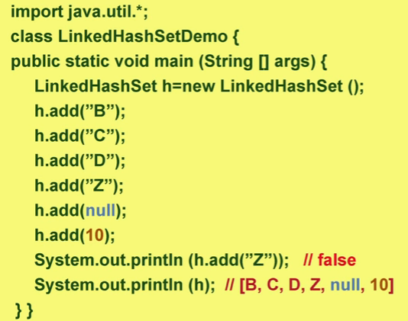

In the case of LinkedHashSet insertion order is preserved.

NOTE: LinkedHashSet is the best choice where we have to develop cache based application as in cache there is no repeat and insertion order in maintained and these 2 condition is satisfied by

LinkedHashSet .

***SortedSet:***

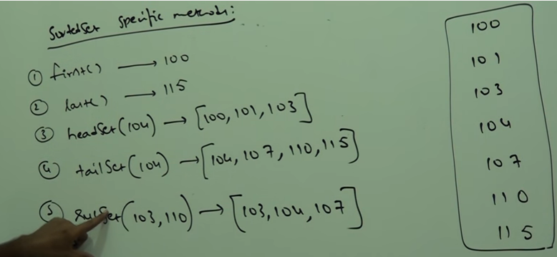

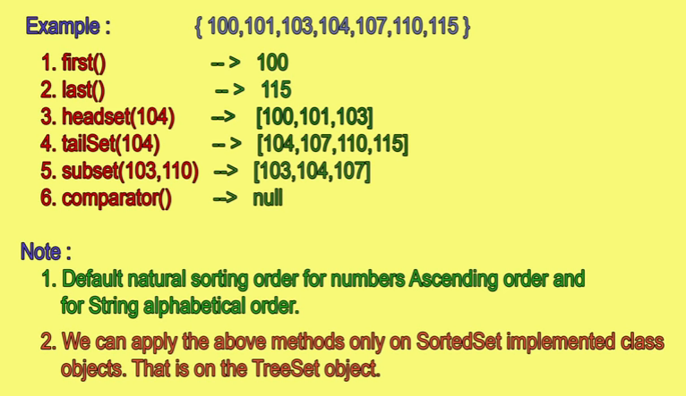

***TreeSet:***

***Constructors in TreeSet class:***

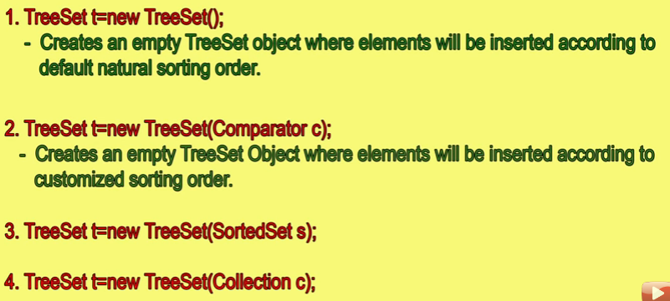

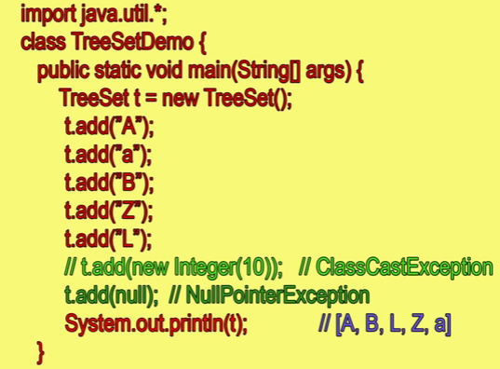

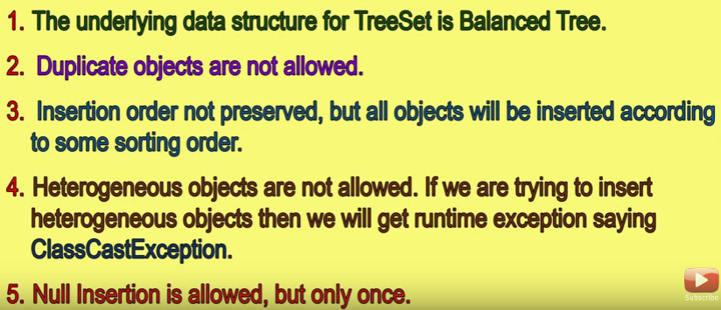

After java 1.6 insertion of null is not allowed.

If we want to insert any element in TreeSet then that element must be homogeneous as well as comparable and this is the reason that we can’t insert StringBuffer object in TreeSet because StringBuffer doesnot implement Comparable interface. If we will try to insert StringBuffer object in TreeSet, we will get ClassCastException.

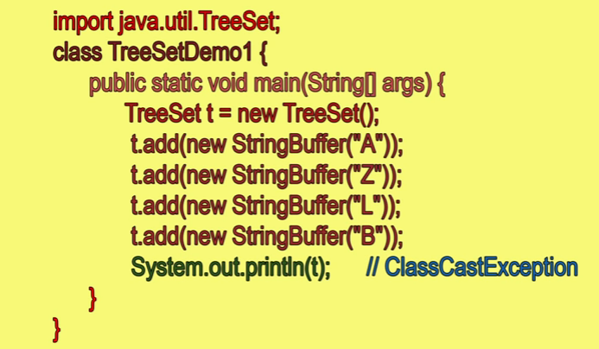

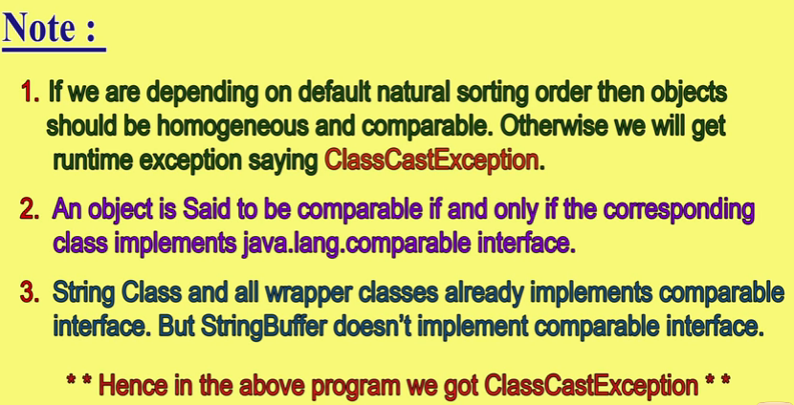

Comparable interface is present in java.lang and contains only one method i.e, compareTo().

public int compareTo(Object obj )

obj1.compareTo(obj2)

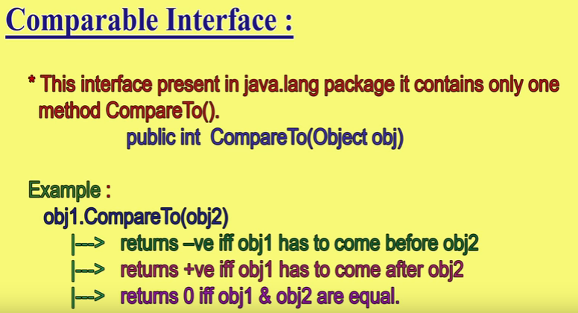

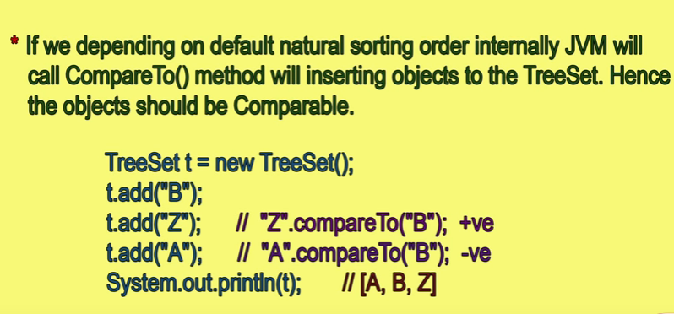

Sometimes we are not satisfied with default natural sorting or that default natural sorting is not available like in StringBuffer then we have to use Comparator interface. It means that comparator is used for customized sorting order and in this the elements must not have to be homogenous as well as comparable.

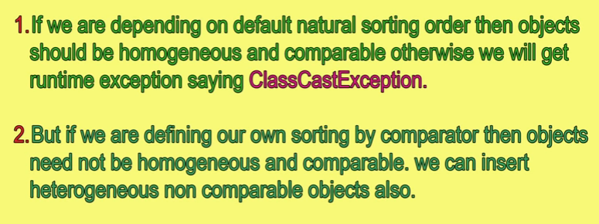

Comparator:

It is present in java.util.

It contains 2 methods:

1. compare() method
2. equals()

to implement equals method is not necessary as equals() is a part of object class and is provided to every class in java by default.

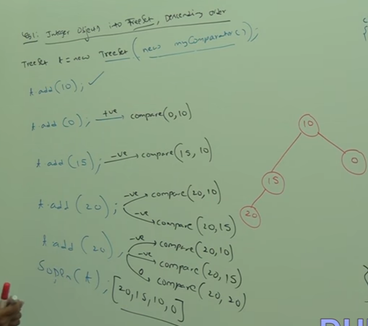

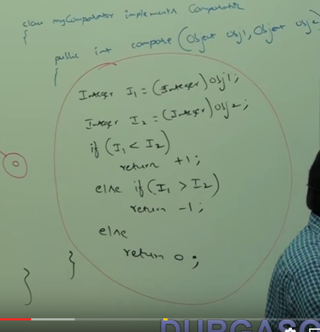

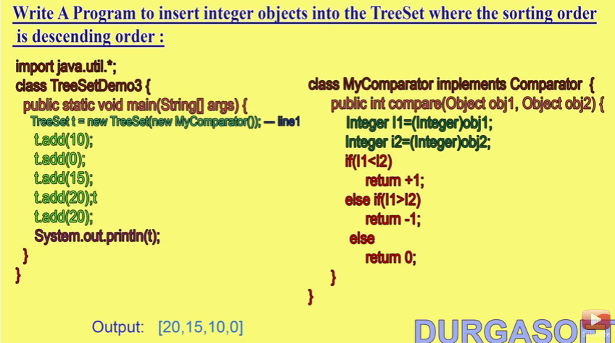

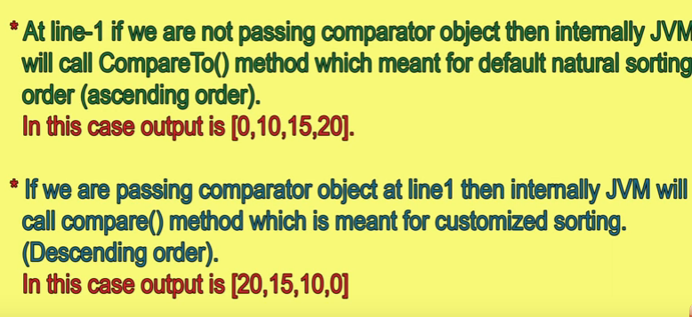

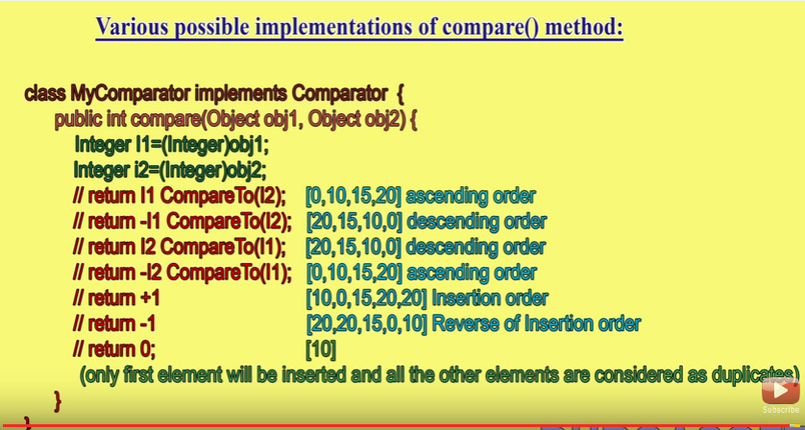

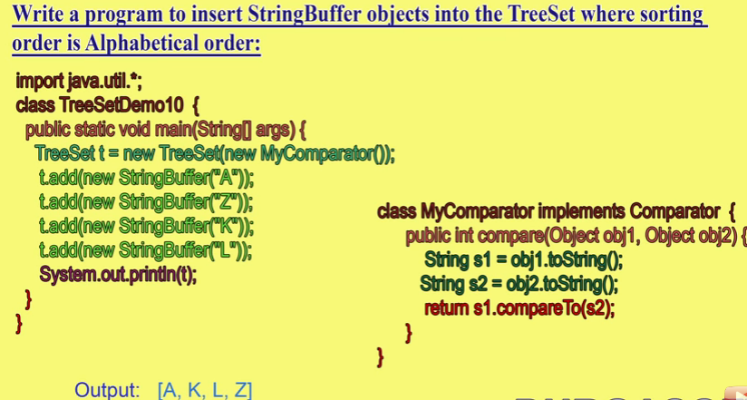

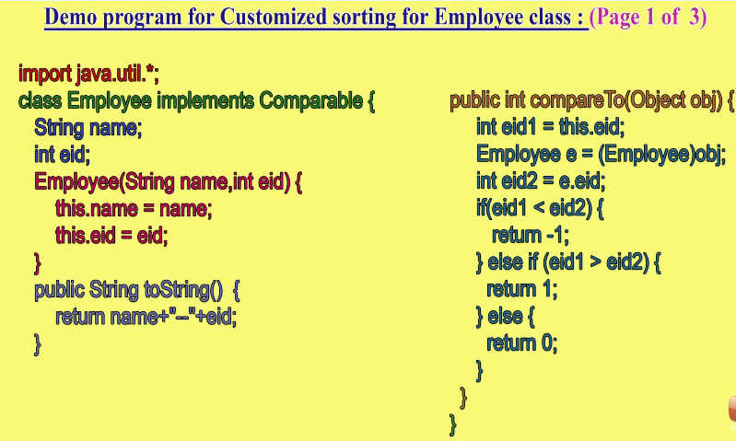

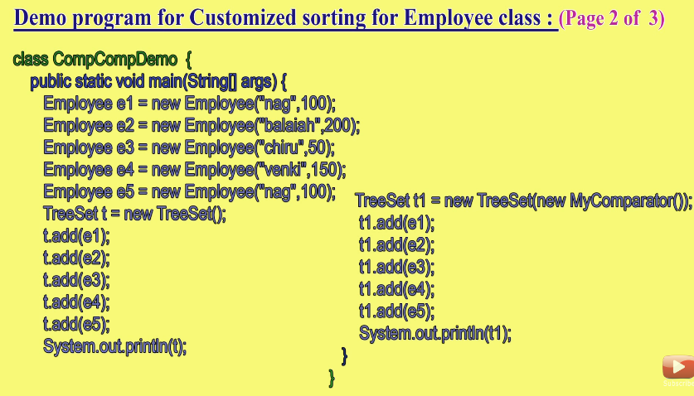

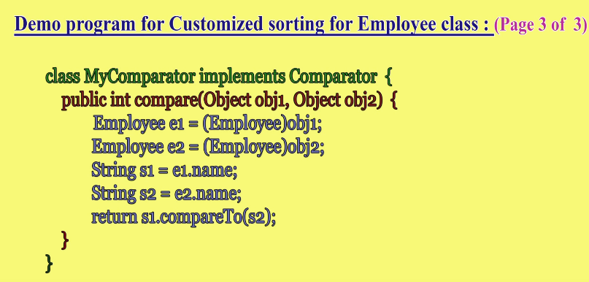

**MAP:**

Map is different from collection as collection deals with the group of objects and Map deals with the key-value pairs. Each KEY-VALUE pair is known as entry. Hence MAP is called collection of Entry Objects. Without existing there is no chance of existing entry object. Hence entry interface is defined inside Map interface.

**Collection views of MAP:**

1. Set keySet(); Entry specific methods.
2. Set entrySet();
3. Collection views();

Here, keys and entries are unique therefore they return Set. As the above are used in MAP therefore they are called Collection views of MAP.

Interface Map

{

.

.

.

Interface Entry

{

Object getKey();

Object getValue();

Object setValue(Object new);

}

}

**HashMap :**

1. Based on Hashtable concept.
2. Insertion order is not preserved.
3. Duplicate keys are not allowed but values are allowed.
4. Heterogeneous keys and values are allowed.
5. Null key is allowed only once
6. Null value can be multiple
7. It is a best choice if the operation is searching.
8. It implements Serializable and Clonable interface but not RandomAccess interface.

***Internal Working of HashMap:***

*HashMap internally has 16 buckets (nodes). Buckets are nothing but the arrays i.e, a[0] to a[15].*

*Entry is the innerclass of Map. When we put an Entry in the map the internal working goes like this:*

*static class Entry<K, V> implements Map.Entry<K, V>*

*{*

*final K key;*

*V value;*

*final int hash;*

*Entry<K, V> next;*

*So, it has key, value, hash code, and the pointer to the next node. So, it uses Linked list.*

***Important:***

*put() method generates hash code of the key and uses this hash code to find the index of the bucket. If the index in empty then the next contains null and if any entry is already present then the next point to the previous value.  
Index of the bucket is calculated by the modulus operation between hashcode and length of the bucket. So. for example if the hashcode is 17 then the index of the bucket will be 17%16 i.e, 1.*

*In get(Key) method also first the hashcode is generated of the key and if more than one elements are present in that bucket(that mean all the elements will have the same hashcode) then equals() method will compare the Keys and if the key is matched then it will return the value of it.*

***In java 8, there is a slight change. If the bucket contains multiple entries and that entries exceeds the threshold(basic threshold: TREEIFY_THRESHOLD = 8) then HashMap internally uses the Balanced tree as it is faster having the worst complexity is O(logn) as compared to the Linked list having O(n).***

**NOTE: Garbage collector can not destroy the object that is associated with the HashMap. If you make the reference of the object null that is associated with the HashMap and then call System.gc() ,garbage collector will come but can’t destroy that object.**

**Constructor:**

1. HashMap hm=new HashMap();

Creates an empty HashMap with a default capacity is 16 and default fill ratio is 0.75.

1. HashMap hm=new HashMap(int initialCapacity)
2. HashMap hm=new HashMap(int initialCapacity, float fillRatio)
3. HashMap hm=new HashMap(Map m)

Difference btw HashMap and HashTable is kind of same as that of the difference btw ArrayList and Vector respectively.

HashMap is non synchronized and hence is not thread safe and because of this is relatively fast.

In hashMap null key value is allowed but in HashTable there is no such concept.

HashTable is Legacy class.

**class** Test {

**public** **static** **void** main(String[] args) {

HashMap hm=**new** HashMap();

System.out.println(hm.put("B", 2));**//null**

System.out.println(hm.put("A", 1));**//2**

Set s1=hm.entrySet();

System.*out*.println(s1);**//[A=1, B=2]**

Set s2=hm.keySet();

System.*out*.println(s2);**//[A, B]**

Collection c=hm.values();

System.*out*.println(c);**//[1, 2]**

Iterator itr=s1.iterator();

**while**(itr.hasNext())

{

Map.Entry me=(Map.Entry)itr.next();

System.*out*.println(me.getKey()+" --- "+me.getValue**());//A --- 1**

**//B --- 2**

}}}

**NOTE: Internally JVM uses .equals() method to find if the key is duplicate or not in HashMap.**

***LINKEDHASHMAP:***

It is the child class of HashMap and is exactly same as HashMap including methods and constructors except the following differences.

1. The underlying data structure is LinkedList+HashTable.
2. Insertion order is preserved.
3. Introduced in 1.4.

LinkedHashSet and LinkedHashMap are commonly used for developing cache based Applications.

***IdentityHashMap:***

It is exactly same as that of HashMap. The only difference is that in normal HashMap JVM uses .equals() method to identify duplicate objects.

And in IdentityHashMap JVM uses == operator to identify duplicate objects.

**class** Test {

**public** **static** **void** main(String[] args) {

String b = **new** String("B");

String b1 = **new** String("B");

HashMap hm = **new** HashMap();

hm.put(b, 1);

hm.put(b1, 2);

System.*out*.println(hm);**//{B=2}**

IdentityHashMap ihm = **new** IdentityHashMap();

ihm.put(b, 1);

ihm.put(b1, 2);

System.*out*.println(ihm);**// {B=2} {B=1}**

}

}

In the above when normal HashMap is used then the output is B=2 as b.equals(b1) is true hence JVM finds them duplicate and therefore it is overridden.

In IdentityHashMap b==b1 results to false and therefore JVM finds no duplicate object and gives the output.

**WeakHashMap:**

It is exactly same as HashMap except the following difference:

In the case of hashMap even though if object doesn’t have any reference it is not eligible for GC if it is associated with HashMap i.e, Hashmap dominates Garbage Collector.

But in the case of weak HashMap, if object doesn’t contain any references, it is eligible for GC eventhough object associated with WeakHashMap i.e, Garbage collector dominates WeakHashMap.

**class** Temp

{

**public** String toString()

{

**return** "Tanuj";

}

**public** **void** finalize()

{

System.*out*.println("Finalized");

}

}

**public** **class** Test {

**public** **static** **void** main(String[] args) {

Temp t=**new** Temp();

HashMap hm = **new** HashMap();

hm.put(t, 1);

System.*out*.println(hm);//Before calling garbage collector

t=**null**;

System.*gc*();

System.*out*.println(hm);//After calling garbage collector

}

}

**OUTPUT:**

**{Tanuj=1}**

**{Tanuj=1}**

**class** Temp

{

**public** String toString()

{

**return** "Tanuj";

}

**public** **void** finalize()

{

System.*out*.println("Finalized");

}

}

**public** **class** Test {

**public** **static** **void** main(String[] args) {

Temp t=**new** Temp();

WeakHashMap hm = **new** WeakHashMap();

hm.put(t, 1);

System.*out*.println(hm);//Before calling garbage collector

t=**null**;

System.*gc*();

System.*out*.println(hm);//After calling garbage collector

}

}

**Output:**

**{Tanuj=1}**

**{}**

**Finalized**

***HashTable:***

**public** **class** Test {

**public** **static** **void** main(String[] args) {

Hashtable h = **new** Hashtable();

h.put(**new** Temp(5), "A");

h.put(**new** Temp(2), "B");

h.put(**new** Temp(6), "C");

h.put(**new** Temp(15), "D");

h.put(**new** Temp(23), "E");

h.put(**new** Temp(16), "F");

//h.put("Durga",null);//NPE

System.*out*.println(h);**//{6=C,16=F,5=A,15=D,2=B,23=E}**

}

}

**class** Temp {

**int** i;

Temp(**int** i) {

**this**.i = i;

}

**public** **int** hashCode()

{

**return** i;

}

**public** String toString() {

**return** i + "";

} }

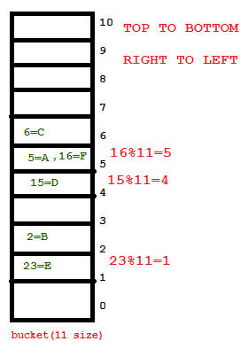

***Concurrent Collections:***

* Underlying structure is HashTable.
* It allows concurrent read and thread-safe update operations.
* To perform read operation thread will not require any kind of lock but to perform write operation, it will require lock but that lock will only be a part of MAP **(Segmented Lock/Bucket Level Lock)** instead of total map lock.
* Concurrent update achieved by internally dividing MAP into smaller portions which is defined by concurrency level.
* The default concurrency level is 16
* It allows any number of read operation but 16 update operations at a time by default.
* Null is not allowed for both keys and values.
* While one thread iterating another thread can perform update operation and ConcurrentHashMap can never throw ConcurrentModificationException.

**CONSTRUCTORS:**

1. ConcurrentHashMap c=new ConcurrentHashMap();
2. ConcurrentHashMap c=new ConcurrentHashMap(int initialCapacity);
3. ConcurrentHashMap c=new ConcurrentHashMap(int initialCapacity,int initialFillRatio);
4. ConcurrentHashMap c=new ConcurrentHashMap(int initialCapacity,int initialFillRatio,int initalConcurrencyLevel);
5. ConcurrentHashMap c=new ConcurrentHashMap(Map m);

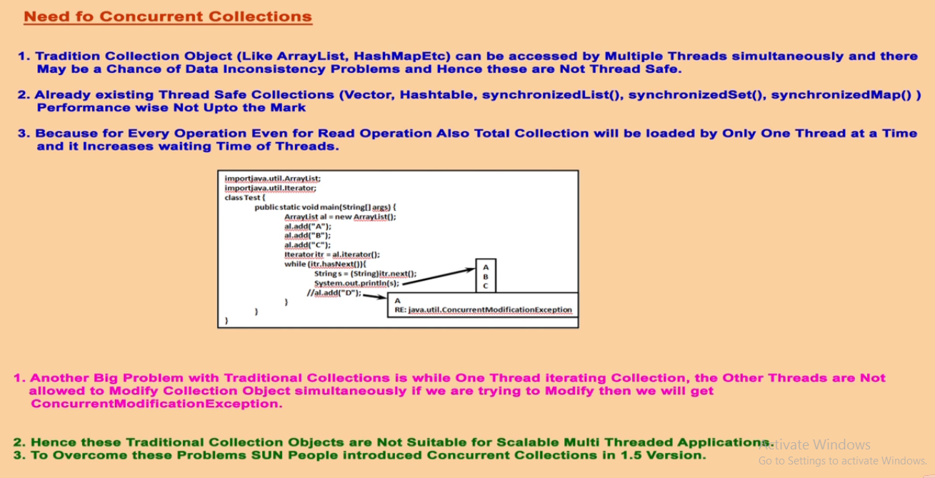

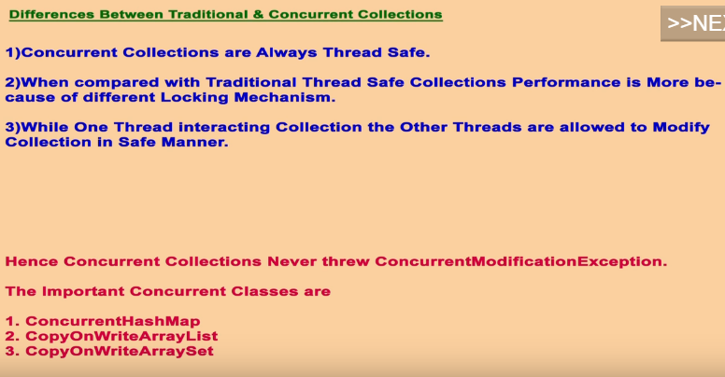

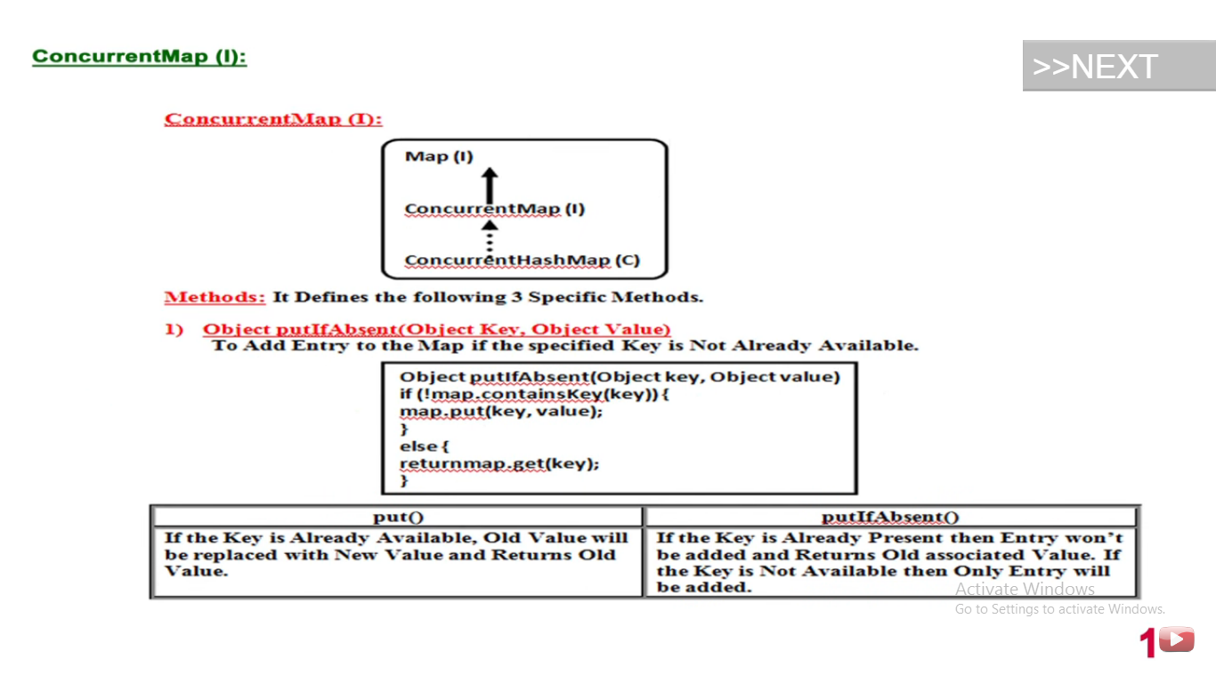

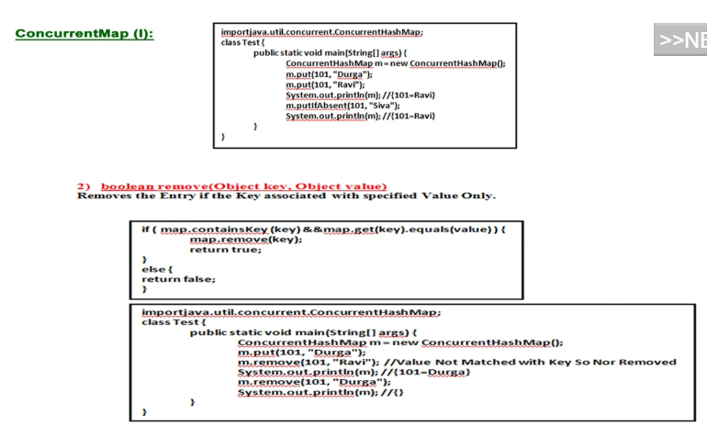

**import** java.util.concurrent.ConcurrentHashMap;

**public** **class** Test {

**public** **static** **void** main(String[] args) {

ConcurrentHashMap c = **new** ConcurrentHashMap();

c.put(1, "A");// returns null

c.put(1, "B");// returns A

System.*out*.println(c);// {1=B}

c.putIfAbsent(1, "C");// returns A

System.*out*.println(c);// {1=B}

}

}

NOTE: In concurrentHashMap, bucket level lock**(Segmented Locking)** is used instead of object level lock.

Normal HashMap is not thread safe and due to this HashTable came in to the picture but in HashTable only one thread is allowed at one time.

Even in Read operation, one thread can operate at a single time. Due to this performance is not up to the mark because waiting time of thread will increase.

This is the reason concurrent collections came into the picture as it allows multi-threading concept.

As in ConcurrentHashMap there are 16 buckets i.e, **concurrency level=16**.

Suppose initial capacity is 16 and concurrency level is also 16 hence for **every 1 bucket one lock is given. This is bucket level locking where initial capacity is equal to the concurrency level.**

Suppose initial capacity is 16 and concurrency level is also 8 hence for **every 2 bucket one lock is given**.

Suppose initial capacity is 16 and concurrency level is 32 hence for **every 1 bucket two locks are given**.

**import** java.util.*;

**import** java.util.Hashtable;

**import** java.util.concurrent.ConcurrentHashMap;

**class** Test **extends** Thread {

**static** ConcurrentHashMap *c* = **new** ConcurrentHashMap();

**public** **void** run() {

**try** {

Thread.*sleep*(2000);

} **catch** (InterruptedException ex) {

}

System.*out*.println("Child thread is excecuting update simultaneously");

*c*.put(103, "C");

System.*out*.println("updated value in 103 key::::" + *c*.get(103));

}

**public** **static** **void** main(String[] args) **throws** InterruptedException {

*c*.put(101, "A");

*c*.put(102, "B");

Test t = **new** Test();

t.start(); **//STARTING THREAD**

Set s1 = *c*.entrySet();

Iterator itr = s1.iterator(); **//ITERATING MAP SIMULTENEOUSLY**

**while** (itr.hasNext()) {

Map.Entry m = (Map.Entry) itr.next();

System.*out*.println("Entry is " + m.getKey() + "-----"

+ m.getValue());

Thread.*sleep*(3000);

}

System.*out*.println(*c*);

}

}

**OUTPUT:**

**Entry is 102-----B**

**Child thread is excecuting update simultaneously**

**updated value in 103 key::::C**

**Entry is 101-----A**

**{103=C, 102=B, 101=A}**

As we can see from output that 103-----C is not available to iterator as there is not a guarantee that updated value must be available to the iterator but if you print the HashMap you will get the total values.

**\*-------------------------------------------------------------\***

**IN CASE OF NORMAL HashMap we will get:**

**Child thread is excecuting update simultaneously**

**updated value in 103 key::::C**

**Exception in thread "main" java.util.ConcurrentModificationException**

**at java.util.HashMap$HashIterator.nextEntry(Unknown Source)**

**at java.util.HashMap$EntryIterator.next(Unknown Source)**

**at java.util.HashMap$EntryIterator.next(Unknown Source)**

**at tanuj.Test.main(Test.java:31)**

If we get ConcurrentModificationException then the iterator is called as Fail-Fast iterator and hence Normal HashMap has Fail-Fast iterator.

If we do not get ConcurrentModificationException then the iterator is called as Fail-Safe iterator and hence ConcurrentHashMap is called Fail-Safe iterator.

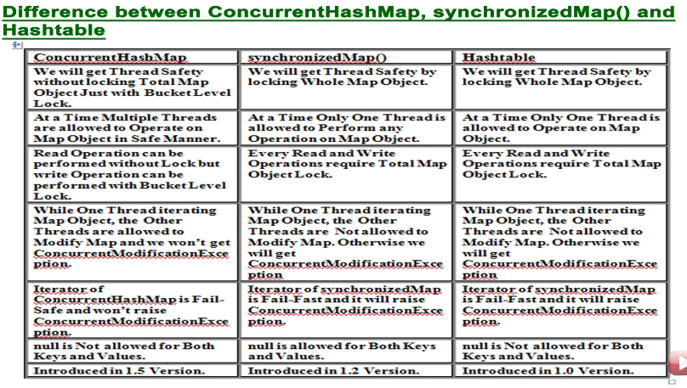

**CopyOnWriteArrayList:**

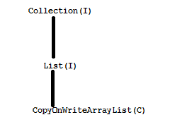

If you want to perform read operation then there is not any problem but if write operation is to be performed then the separate copy(Clone) of the CopyOnWriteArrayList is created and on the copy the write operation is performed and we will get thread safety because of that.

Suppose if 1000 threads are to be there to perform write operation, then 1000 copy of that CopyOnWriteArrayList is to be created and that will result into the performance issue. Hence if there are less number of threads then this is recommended but if there are large number of threads are there then it is the worst choice.

It is same as Normal ArrayList, the only differences are:

ArrayList is not thread safe i.e, we will get ConcurrentModificationException if another thread try to modify the ArrayList Object at the same time with another thread. This Exception does not arise in the case of CopyOnWriteArrayList as we don’t get ConcurrentModificationException.

**class** Test **extends** Thread {

**public** **static** **void** main(String[] args) {

CopyOnWriteArrayList<Integer> a=**new** CopyOnWriteArrayList<Integer>();

a.add(1);

a.add(2);

a.add(3);

Iterator<Integer> itr=a.iterator();

**while**(itr.hasNext())

{

Integer i=itr.next();

**if**(i%2==0)

{

itr.remove();//java.lang.UnsupportedOperationException

}

}

}

As it is the child class of List therefore all the methods in the List are applicable to CopyOnWriteArrayList. Including all the List methods there are two new methods:-

1. boolean addIfAbsent()
2. int addAllAbsent(Collection c)

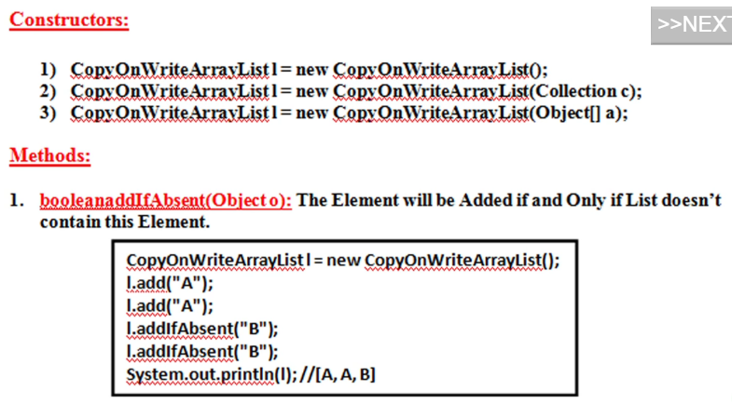

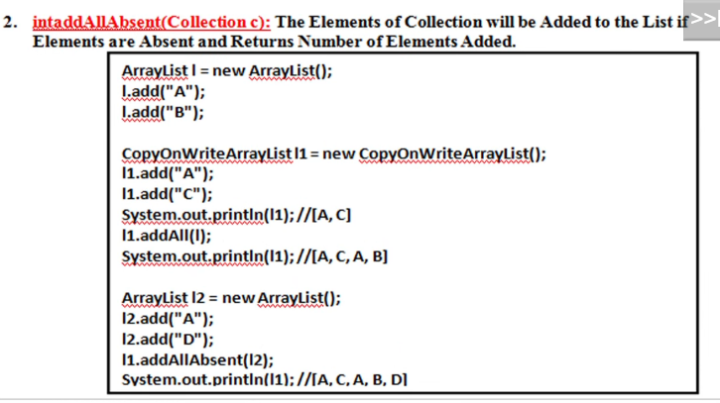

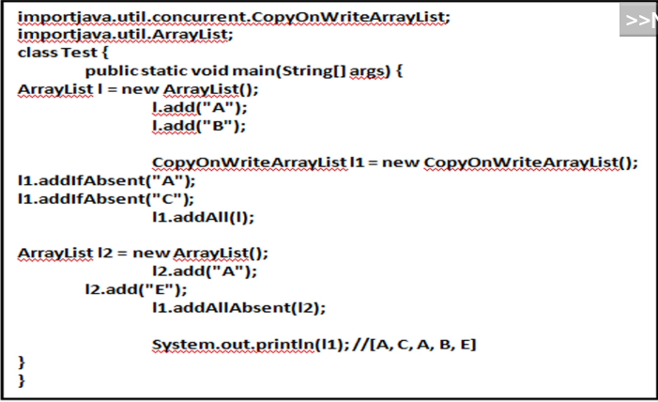

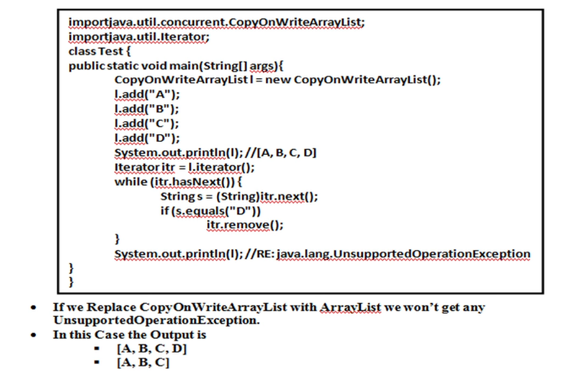

**CopyOnWriteArrayList:**

**class** Test {

**public** **static** **void** main(String[] args) {

CopyOnWriteArrayList<Integer> a=**new** CopyOnWriteArrayList<Integer>();

a.add(1);

a.add(2);

a.add(3);

Iterator<Integer> itr=a.iterator();

a.add(4);

**while**(itr.hasNext())

{

Integer i=itr.next();

System.*out*.println(i);**//[1,2,3]**

}

System.*out*.println(a);**//[1,2,3,4]**

}

**NORMAL ArrayList**

**class** Test {

**public** **static** **void** main(String[] args) {

CopyOnWriteArrayList<Integer> a=**new** CopyOnWriteArrayList<Integer>();

a.add(1);

a.add(2);

a.add(3);

Iterator<Integer> itr=a.iterator();

a.add(4);

**while**(itr.hasNext())

{

Integer i=itr.next();

System.*out*.println(i);

}

System.*out*.println(a);

}

Output:

**Exception in thread "main" java.util.ConcurrentModificationException**

**at java.util.HashMap$HashIterator.nextEntry(Unknown Source)**

**at java.util.HashMap$EntryIterator.next(Unknown Source)**

**at java.util.HashMap$EntryIterator.next(Unknown Source)**

**at tanuj.Test.main(Test.java:31)**

***CopyOnWriteArraySet:***

